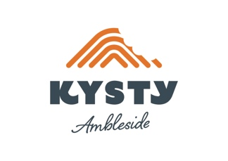

Lunch Menu
Two courses £27.50
Three courses £32.50

To start

Morecambe Bay Shrimp, saffron oil, spiced cauliflower velouté
‘Secateur’ Chenin Blanc, A.A. Badenhorst, S. Africa, 2021
Pouilly-Fuissé, Domaine Cornin, Burgundy, France, 2018

Wood Pigeon, beetroot, blackberry, shallot, rye sourdough
DAO Tinto, Prunus, DAO, Portugal, 2018
Franco de Porc, Domaine de la Chevalerie, Burgueil, France, 2018

Heirloom Tomatoes, Allerdale, verjus, basil, rye
Beck Pink, Judith Beck, Burgenland, Austria, 2021
Cheverny Blanc, Domaine du Salvard, Loire, France, 2020

Main course

Guinea Hen Breast, hen of the woods, sour onion, grains, Cumbrian chorizo
Pinot Nero, Castel Firmian, Mezzacorona, Trentino, Italy, 2019
Chianti Classico ‘Ama’, Castello di Ama, Tuscany, Italy, 2018

Stone Bass, kohlrabi, poached carrot, black garlic, lovage
‘Gorro’ Loureiro, Portugal Wine Boutique Winery, 2020
Cheverny Blanc, Domaine du Salvard, Loire, France, 2020

Hispi Cabbage, king oyster, hazelnut, miso dressing
‘Secateur’ Chenin Blanc, A.A. Badenhorst, S. Africa, 2021
Pinot Nero, Castel Firmian, Mezzacorona, Trentino, Italy, 2019

To finish

Gingerbread Cheesecake, blackberries, blackberry sorbet, gingerbread tuile
Monbazillac, Domaine de L’Ancinne Cure, Dordogne, France, 2015

Chocolate Delice, scorched cherry, cherry sorbet, white chocolate & coffee ganache
Maury Grenat, Domaine Lafage, Roussillon, France, 2020

Sea Buckthorne Curd, white chocolate ice cream, raspberry
Petit Manseng Doux ‘Le Luy’, Domaine de Cabidos, France, 2016

